Cell Therapy Clinical Trials and the Mad Dash to Japan

Posted by Vin Singh on Sep 27, 2016 10:44:00 AM

When Shinzo Abe was re-elected as Japan's Prime Minister he aggressively embarked on a challenge to revive Japan's struggling economy. With the introduction of Abenomics, an economic policy that includes "three arrows" of fiscal stimulus, monetary easing, and structural reforms, the ball was set in motion to redefine Japan's standings within the global market.
In November 2014 the Japanese government approved the Act on the Safety of Regenerative Medicine (ASRM) which provided a progressive new framework for development and approval of regenerative medicine products. This, in conjunction with the long standing Pharmaceuticals and Medical Device Act (PMD), may enable Japan to become the new global epicenter for cell therapy.
In this blog, we'll address how these regulations are impacting cell therapy clinical trials conducted by the biopharmaceutical industry on a global scale.
The Streamlined Regulatory Process
The national focus on regenerative medicine and cell therapies in Japan, coupled with Abenomics, paved an accelerated pathway for a new regulatory system to be put in place. According to Toshio Miyata, executive director of the Health and Global Policy Institute in Japan, "the new approval system for the commercialization of cellular therapy products would move approval from the end of clinical trials to a stage intermediate between the confirmation of probable benefit and safety and marketing with further confirmation of efficacy and safety to follow." As the figure below (courtesy of National Academy of Sciences) indicates, this new regulatory framework expedites the clinical development process by limiting the amount of time, and money, spent in the clinical trial phase.
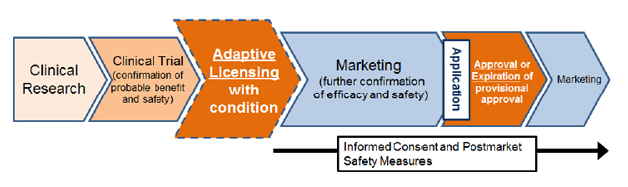The Road to Commercial Success
In September of 2015, Terumo was the first company to receive conditional Japanese regulatory approval under the ASRM for their product called Heartsheet®. This innovative ex vivo product is a treatment using autologous skeletal myoblast sheets for treating severe heart failure caused by chronic ischemic heart disease. Cells are taken from a patient’s thigh and cultured. Then five myoblast sheets are applied to the surface of the heart. The conditional approval comes with specific criteria for numbers of cases, demonstrated efficacy, and regular market approval within 5 years.
According to Terumo, estimates are that the product will be used in 20 to 30 cases per year for treatment. The price for Heartsheet® is US $122,000. Japan’s NHI (National Health Insurance) will cover 10%-30% of the cost. The product has been classified as a medical device unlike TemCell®, which I’ll discuss in further detail below.
In November of 2015, Mesoblast Ltd. in partnership with JCR Pharmaceuticals Co. Ltd. received full regulatory approval in Japan for their allogeneic mesenchymal stem cell product TemCell® HS Inj. for use in Acute Graft-versus-Host Disease which is to be used after bone marrow or hematopoietic stem cell transplants. Treatment will be in the form of 72 million cell doses in a bag with a total of 16 – 24 doses in total depending upon the persistence of symptoms. Each dose will be reimbursed by Japan’s NHI at $7,079 US. The total treatment cost may be as high as $170,000. This product is classified as a pharmaceutical. Although approved based on a small trial, this product demonstrated statistically significant results which enabled full market approval, unlike Heartsheet’s conditional approval.
The Big Question
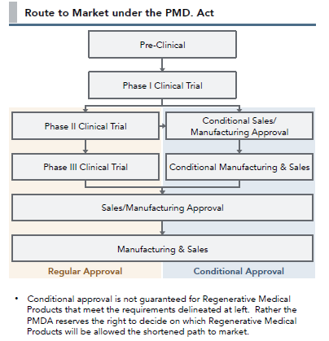

Will there be a global rush to Japan for a chance at a faster and more economical path to the market? It’s an opportunity for cash starved, fledgling cell therapy companies to validate their technology and acquire early revenue.
This diagram (courtesy of CJ Partners) illustrates the two potential paths for regenerative medicine. Depending on the complexity and other risk factors, there is an opportunity to conduct a small phase1/2 trial followed by seven years of conditional market approval. This is a very intriguing proposition and an important strategic consideration for cell therapy companies worldwide.
Although there are some challenges associated with conducting business in Japan, the new regulatory changes are already showing evidence of driving companies to partner and conduct clinical trials. If Japan's changed approach to the industry proves to be as effective as they hope it to be, perhaps other countries' regulatory bodies will follow lead, eventually lowering the hurdle for getting cell therapies to market.

